**#capture image of person and detect dominant emotion**

***#google colab camera capture snippet :used to capture user picture***

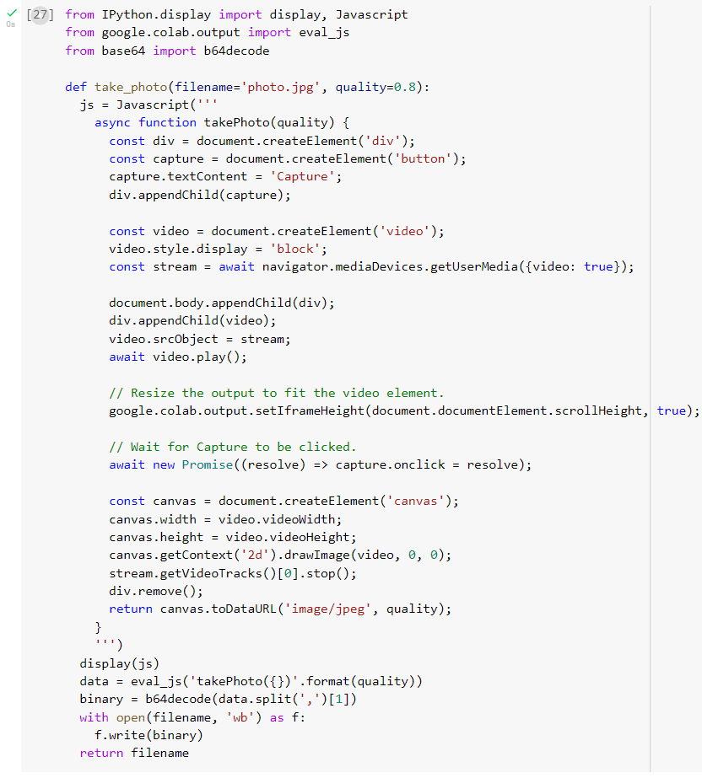

#google colab camera capture snippet which saves the captured image in files

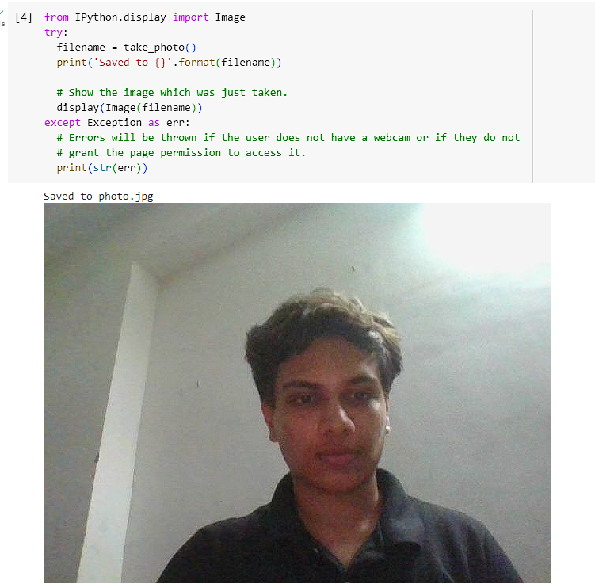

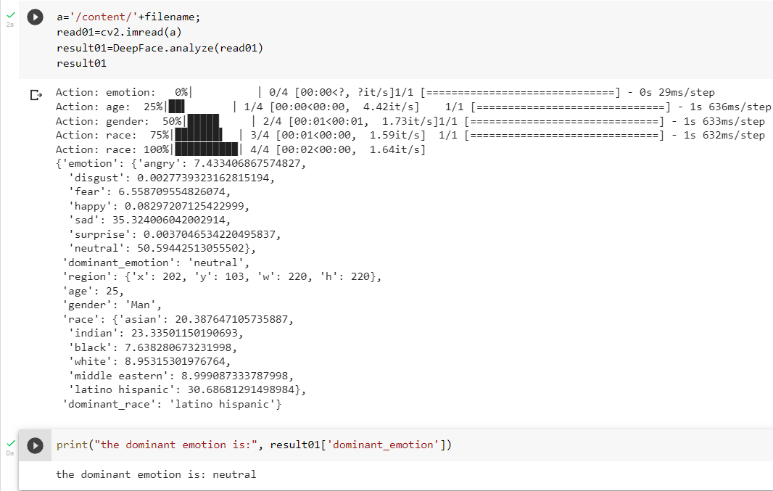

**#capture image of person and verify the person**

#google colab camera capture snippet which saves the captured image in files

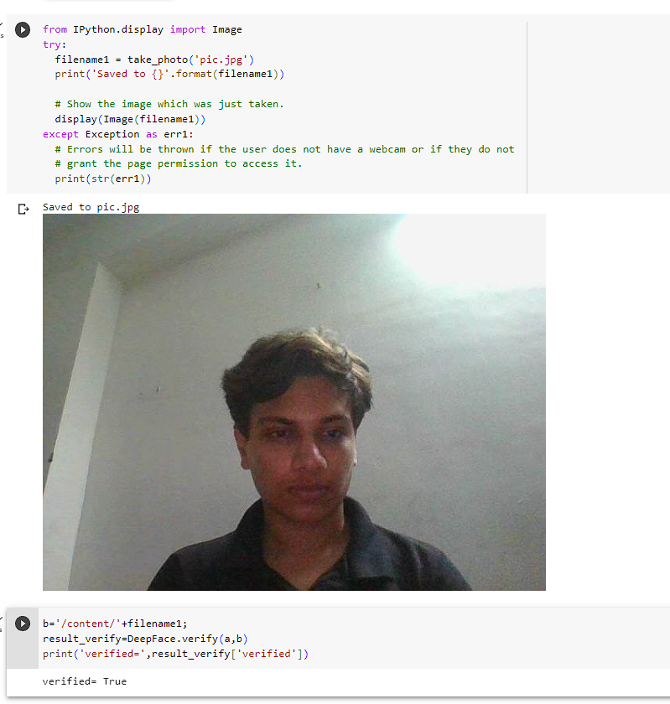

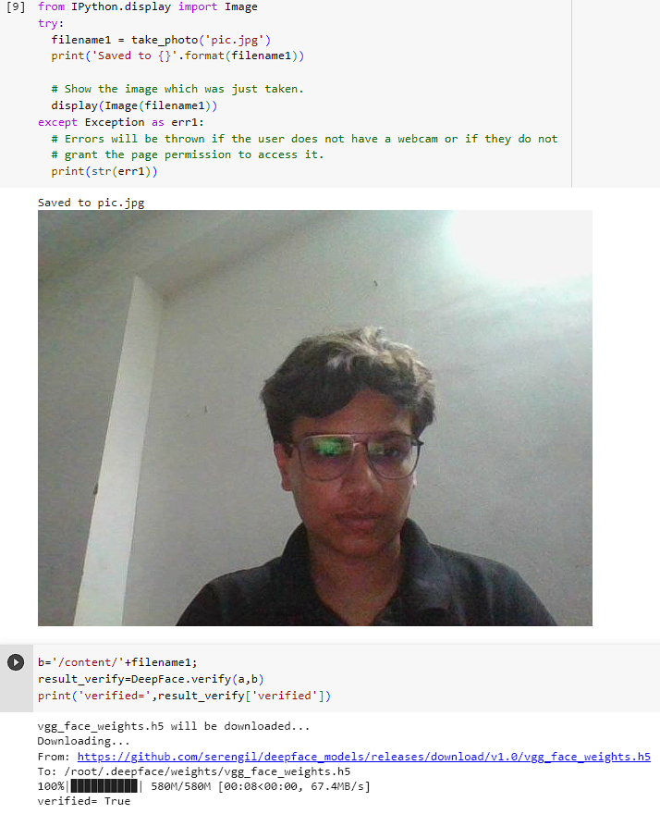

*#DeepFace.verify is used to verify and identify if the person in both image is same or different*